1(a).

Summary :

In this era , update and innovation happens daily. In terms of software engineering process model it also same . So from that point I need to develop a process model that is mixed of agile and v model for minimizing their issues and build them simpler. .The unsteady necessities of rising a carried package and accumulative price of operational package are imposing researchers and consultants to work out innovative and superior means that for rising package application at slight business or at enterprise level are viewing for. Agile methodology has its own edges however there are deficiency many of the options of ancient package development methodologies that are essential for fulfill. That’s why an embedded approach are the correct declare package trade instead of a pure agile approach. This analysis shows however agile embedded ancient will play a significant role in development of package. A survey conducted to seek out the impact of this approach in trade. each qualitative and measuring performed.

Introduction:

Software development method model have designed to keep up all the relationships connected with specific package and obtain a prosperous out come back. Agile is one in every of the simplest model during this term and v model even have some profit except for a lot of advance output it'll be terribly effective if each agile and v works along. we are able to say it mix of agile and v model or mixed agile with v model.

There are totally different kind and different intellectual level of stakeholders that have different responsiveness, activities and views with relation to the wants. For this agile embedded ancient V model approach is best work. It’s a user focused approach. There would be lowest probabilities of package failure if all indicated stakeholders ensure utterly famed necessities. It’s a most problematic task to visibly discover the wants for altered deliverables because it proves the package that it'll be effective or not. It became a lot of problematic to pick out for strictly distributed stakeholders for necessities. For presenting innovative and contemporary package development technique, it's presumptuous that it'll enhance the potency and productivity of package designers, testers, briefly entire package crew. package production will be explained as proportion of productivity factory-made by package team and assets utilized by them. The authorities developed productivity connected queries are: Is package team performance greatest because it consider? are team participants in opposition? Is effort being successful? thus entirely replied gather by applying agile embedded ancient V model. By applying this approach for package development and testing team are ready to turn out very discovered documents to work out assets that are utilised to calculate the total of productivity turn out. For the assessment of package dimension between development amount options of agile embedded v model can improve package team output. Organizations are victimization agile because of its flexibility of your time amount epoch and set up.

Agile development methodology offer emphasize on individuals rather than processes. Maturity enhance by less attention on detail processes are outline and enhance perception of agile practitioners and amount of practices with content investigation of the qualitative knowledge. Maturity in agile enhance maintenance, assurance, cooperation, and proficiencies in organizations among development team. once stockholders doesn't perceive what need it becomes troublesome to develop a desired product because the user want or if not properly realize it might cause failure of developed package. This feature of agile are versatile cause numerous drawback of integration. Whereas entity modules will be developed utterly helpful cannot perform as AN application once integrated. Methodologies agile package development characterised by little cycle reiterative and progressive development user participation in improvement time box mutual higher cognitive process merger of speedy response. once there's confidence in individuals rather than predefined method like a socio technical procedure of the team members, client, company AN interaction designer and a member of the opposite team members.

1(b).

Here have three sections. Agile and V are previous sections and new one is mixed of them.

1.Agile package development:

Agile could be a method that helps groups give fast and unpredictable responses to the feedback they receive on their project. It creates opportunities to assess a project's direction throughout the development cycle. Teams assess the project in regular meetings called sprints or iterations.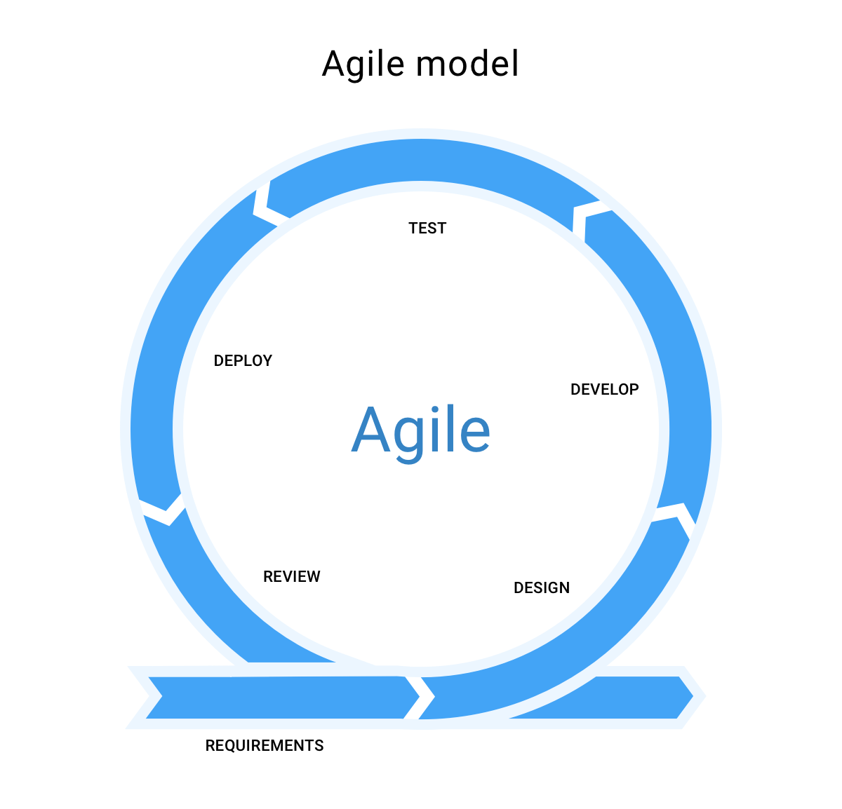

Principals of Agile:

1. Customer satisfaction through early and continuous software delivery

2. Accommodate changing requirements throughout the development process

3. Frequent delivery of working software

4. Collaboration between the business stakeholders and developers throughout the project

5. Support, trust, and motivate the people involved

6. Enable face-to-face interactions

7. Working software is the primary measure of progress

8. Agile processes to support a consistent development pace

9. Attention to technical detail and design enhances agility

10.Simplicity

11. Self-organizing teams encourage great architectures, requirements, and designs

12. Regular reflections on how to become more effective.

V model:

The V-model is a type of SDLC model where process executes in a sequential manner in V-shape. It is also known as Verification and Validation model. It is based on the association of a testing phase for each corresponding development stage. Development of each step directly associated with the testing phase.

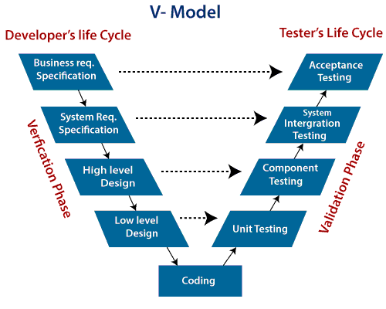

Proposed mixed of agile and v model theorem:

Agile has abundant wide blessings over set up driven development. V model and standards apply in programming improvement. they provide answers for the problems after they use in programming advancement. Agile as of currently has increased the generation quality instead of arrangement driven methodologies.

• unendingly cooperation with shopper to incorporate appreciation.

• client joint effort for the duration of the event of code.

• needs dynamic area unit welcome.

• Throughout development of code to meet the shopper.

• Throughout the necessity dynamic area unit invited.

Now mix them with the simplest a part of each model required and create it a lot of helpful. The result of this integrated approach checked through a survey on code business. totally different attributes area unit checked and its effects on code on development. The survey is finished to make sure what's going to be the results on code business code maturity Attribute, whereas mistreatment standards for safety important code systems. code persons associated with code business.

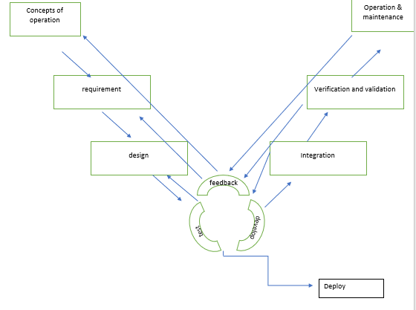

Software maturity accomplishment is that the basic purpose of this analysis. According to the customer quality is to satisfy his demand at an appropriate level of value. per user quality is straight forward to use and work with computer code. per developer quality is straight forward to style, maintain and utilize software’s elements and per developer quality is low development value additionally as high client satisfaction. to satisfy these demands our approach can use a form that stuffed by totally different

Features of this model:

1.Reduction of project risk

The reason advancement model enhances the simplicity of the task and venture management by

determining reliable methodologies and unfurling the next results and accountable elements.

2.Improved quality

As the procedure model uses set of institutionalized procedures that guarantee the discoveries to

be given are finished and having needed quality.

3.Total value reduced

By choosing fitting model for each improvement stage expense of the venture diminished.

4.Scalability

It is the capability of the breed method model to be versatile in term of venture size. It

functions laudably for small to mega calculable ventures

2(A).

Testing Strategies: In this section it will work with TA. That means Testing and acceptance stage, during this step of development cycle the necessary purpose to recollect ar the following:

style of take a look at Cases (There are one legal action for one Individual demand, each demand can have its own legal action style for specifically to see that demand and with its implementation checking.)

– Unit take a look at

Unit testing could be a form of computer code testing wherever individual units or elements of a computer code are tested. the aim is to validate that every unit of the computer code performs obviously. Unit Testing is completed throughout the event (coding phase) of Associate in Nursing application by the developers. Unit Tests isolate an area of code and verify its correctness. A unit is also a personal operate, method, procedure, module, or object.

– Acceptance take a look at

Acceptance testing, a testing technique performed to work out whether or not or not the package has met the necessity specifications. the most purpose of this take a look at is to guage the system's compliance with the business needs and verify if it's has met the desired criteria for delivery to finish users.

– Integration take a look at

System Integration Testing is outlined as a sort of computer code testing dispensed in Associate in Nursing integrated hardware and computer code setting to verify the behavior of the entire system. for instance, computer code and/or hardware elements ar combined and tested more and more till the whole system has been integrated.

– System take a look at

System could be a level of testing that validates the entire and totally integrated wares. the aim of a system take a look at is to the end-to-end system specifications. System Testing is really a series of various tests whose sole purpose is to exercise the complete computer-based system.

– Functional take a look at

Functional testing consists of testing the interface between the applying on one aspect and therefore the remainder of the system and users on the opposite aspect. it's a way of making certain that project/product works because it ought to and what users expect it to try to historically, practical testing is enforced by a team of testers.

Here unit testing outcomes solely like binary either pass or fail means that affirmative or no. Like unit take a look at the acceptance test suggests additionally what's truly the rationale of failure and applicable things which will be additionally tell. Integration is additionally referred to as definition of done, testing within which each elements (software and hardware) are combined to assure either that they each will move and join forces with one another per expectations and needs to convey the user the desired output. There ought to be a testing setting specifically thus shut reflects to original.

2(b):

Best Testing methodology for my method model :

The best testing methodology of this model is acceptance or user acceptance methodology . we all know that v model is termed as validation and verification model and agile is appropriate for gift era thus if we have a tendency to mix this 2 method model then it'll be best for user acceptance half and lift secure man management of the SDLC. User acceptance testing is a minimum of as rigorous during this project development techniques. As significantly, during this model UAT techniques are applied a lot of earlier within the development method providing earlier feedback to the team. Earlier feedback reduces work by finding and fixing issues before they'll get larger. several UAT activities are the part of the quality practices as well as acceptance take a look at cases in user stories and generating interactions with stakeholders in demonstrations. once want additional activities are simply integrated into Agile development techniques like adding UAT tasks in developing stories or embrace UAT specific sprints. UAT activities build trust with stakeholders. UAT additionally proves to stakeholders that weren't concerned within the Agile development method that project is delivering on the business desires. User acceptance testing could be a necessary step in any project, during this model it simply spreads it out and will it earlier (and better).

3(a):

Video link:

3(b):

Conclusion:

We have found a survey conducted to see the results of integration of each agile and ancient v model and systematic review of literature conducted to see out the results of this integrated. approach. this can be Associate in Nursing empirical study for computer code business. The results of this survey provides positive responses for higher improvement of quality, efficiency, quality, maintainability, and reduces the time and value that could be a nice profit. There have mentioned some limitations on it analysis but it's recommended that for any analysis to boost this analysis as during this work the sample size is incredibly low and knowledge collected is little. If the dimensions of information is little it'll facilitate in understandings additional effectively and clearly.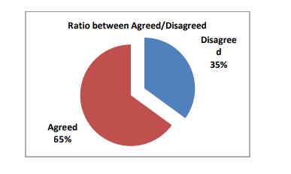

References :

1. <http://www.indianjournals.com/ijor.aspx?target=ijor:ijmie&volume=7&issue=2&article=024>

2. <https://www.javatpoint.com/software-engineering-agile-model>

3. <https://www.analyticssteps.com/blogs/7-types-agile-methodologies>

4. https://www.geeksforgeeks.org/dynamic-systems-development-method-dsdm/

5.https://www.agilebusiness.org/page/ProjectFramework_02_ChoosingDSDM